Assignment 1: Creating Job on Jenkins to install Apache httpd Server:

Step 1: Login on Jenkins dashboard as below. And click on > + New Item
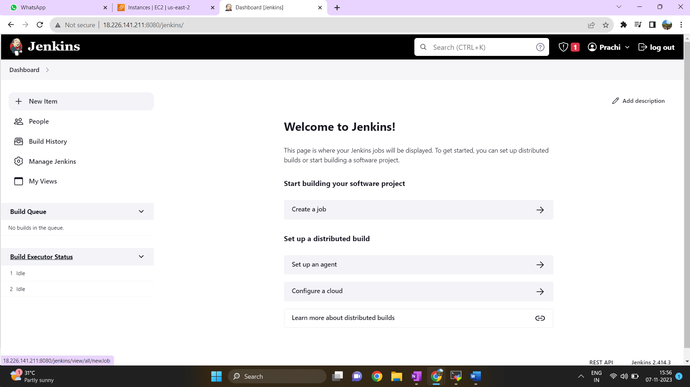
Step 2: Enter an item name > Choose Freestyle Project > Click on OK
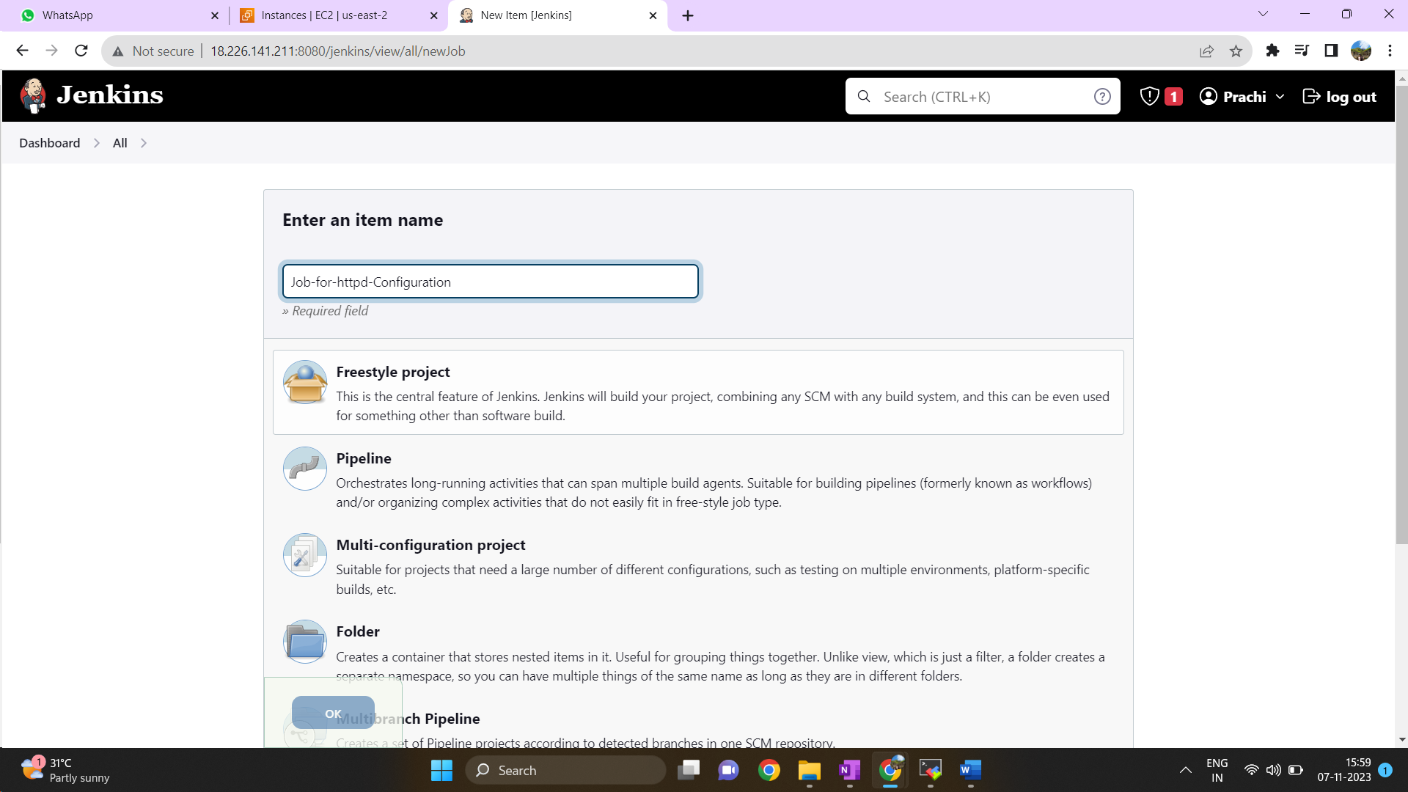

Step 3: Add a Description about your Job > Go to Build Steps select Execute Shell and write your Shell Script > Click on Apply and Save.
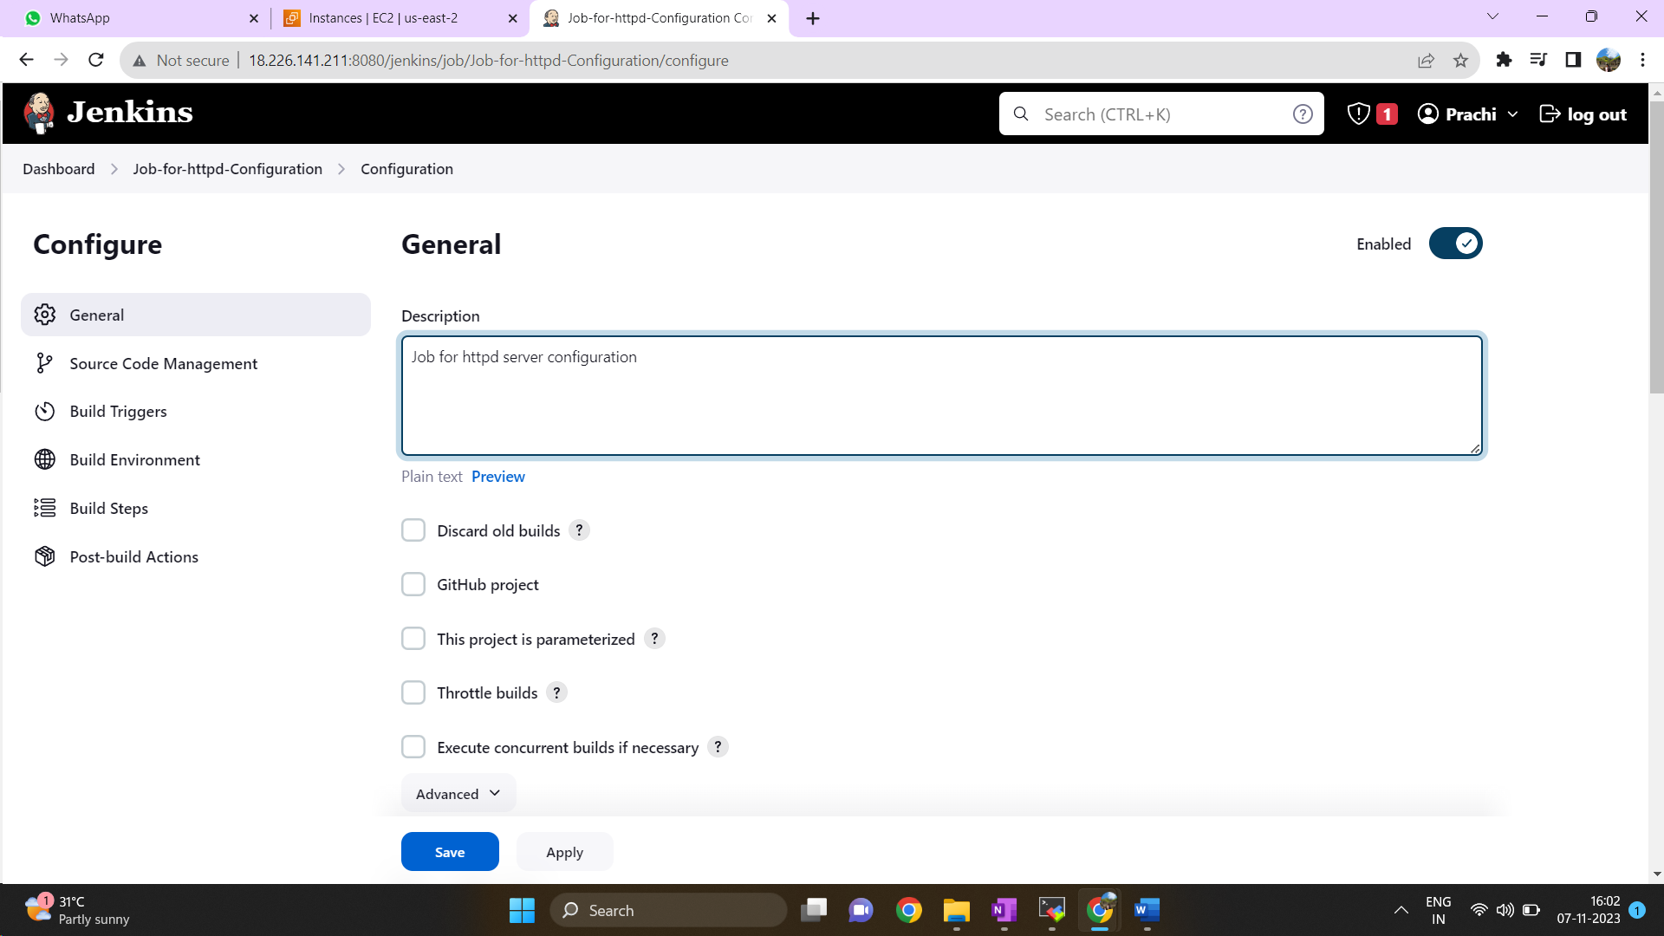
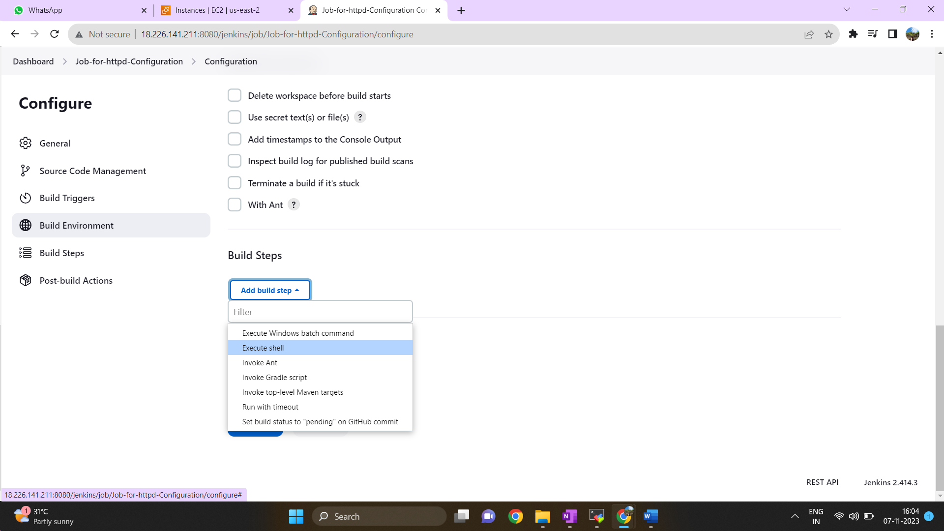
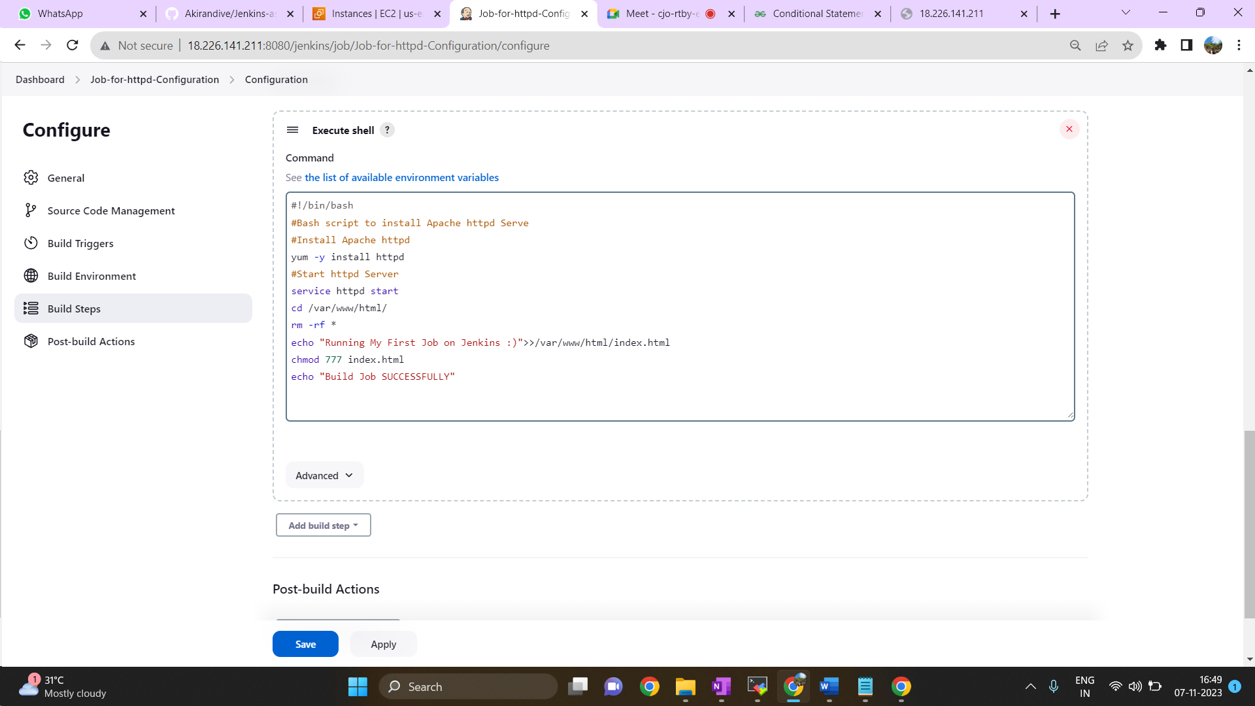

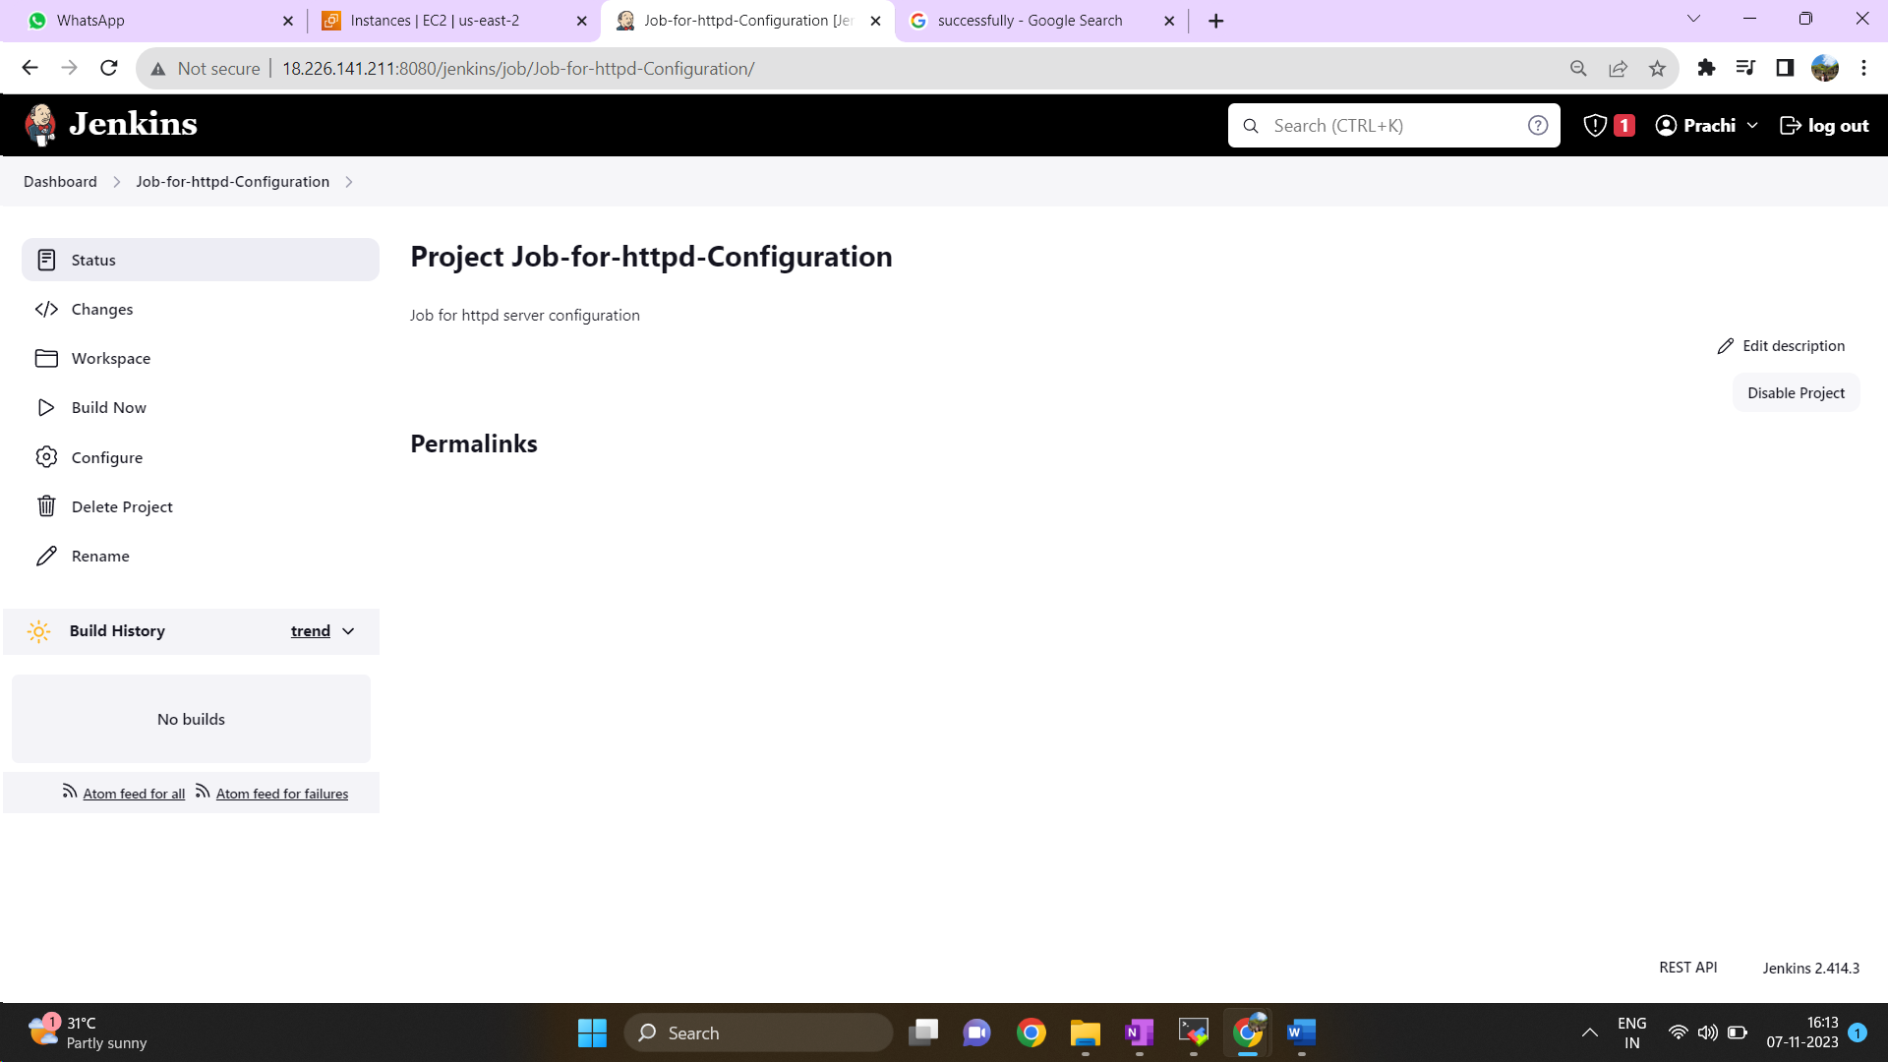
Step 4: Click on Build Now to run a job
Step 5: Go to console output to check
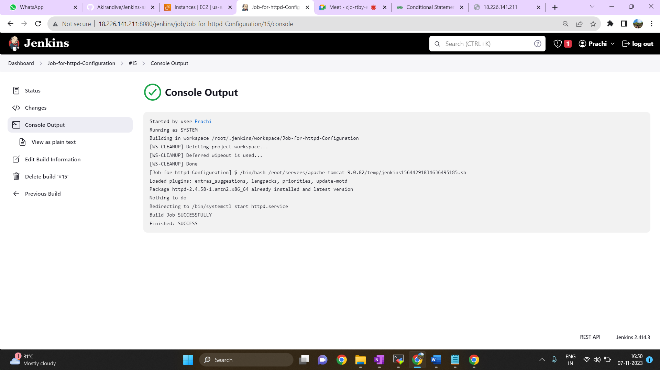
Step 6: Access the Web server using public IP.


